

CZ2003 Computer Graphics and Visualization

Lab 5: Morphing

ACHARYA ATUL

U1923502C

SSP1

**Defining the Required Shapes**

Defining two shapes for the following morphing experiment:

Number in attendance list: 1

Numeric part of Lab Group: 1

Therefore, the required shapes are:

* Formula 1:
* Formula 2:

|  |  |
| --- | --- |
| **Formula 1** | **Formula 2** |
| The first shape to be defined is formula 1.  It can be found in the file “**Lab_5_Formula_1.wrl**”.  The definition of the shape is:  x = 1.6(cos(ϕ))3  y = 1.6(cos(θ)sin(ϕ))3  z = 1.6sin(θ)sin(ϕ)  where  0≤θ≤2π and 0≤ϕ≤π  By modifying the parameters so that they are in the same range, we get:  x = 1.6(cos(πv))3  y = 1.6(cos(2πu) sin(πv))3  z = 1.6sin(2πu) sin(πv)  where  0≤u≤1 and 0≤v≤1  Sampling Resolution [50 50]  Below is a snapshot of the file “**Lab_5_Formula_1.wrl**”:    Associated Wireframe: | The first shape to be defined is formula 1.  It can be found in the file “**Lab_5_Formula_2.wrl**”.  The definition of the shape is:  x = 1.5acos(θ)  y = 1.5asin(θ)cos(θ)  z = 1.5a(sin(2aπ))5  where  0≤θ≤2π and 0≤a≤1  By modifying the parameters so that they are in the same range, we get:  x = 1.5vcos(2πu)  y = 1.5vsin(2πu) cos(2πu)  z = 1.5v(sin(2πv))5  where  0≤u≤1 and 0≤v≤1  Sampling Resolution [50 50]  Below is a snapshot of the file “**Lab_5_Formula_2.wrl**”:    Associated Wireframe |

**Implementing Morphing of Formula 1 to Formula 2**

The morphing is implemented as follows:

x1 = 1.6(cos(πv))3

x2 = 1.5vcos(2πu)

x = x1 + t(x2-x1)

y1 = 1.6(cos(2πu) sin(πv))3

y2 = 1.5vsin(2πu) cos(2πu)

y = y1 + t(y2-y1)

z1 = 1.6sin(2πu) sin(πv)

z2 = 1.5v(sin(2πv))5

z = z1 + t(z2-z1)

The range of t is from [0 1]. But internally it is mapped to a period of 7 seconds. That is, Shape 1 morphs into shape 2 in 7 Seconds.

Domain: [0 1 0 1]

Resolution: [50 50]

Colour:

r = fabs(sin(4πt))

g = t

b = 1 – t

Below is a snapshot of “**Morphing.wrl**”:

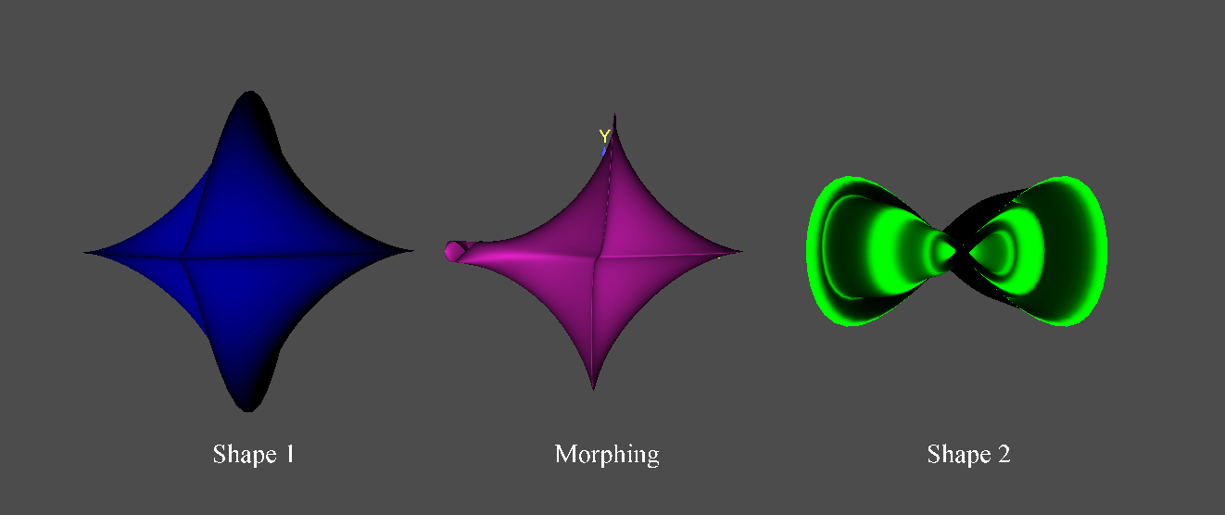

Below is the associated wireframe:

